**DAILY ONLINE ACTIVITIES SUMMARY**

|  |  |  |  |  |  |  |  |  |
| --- | --- | --- | --- | --- | --- | --- | --- | --- |
| **Date:** | **22/05/2020** | | | | | **Name:** | **PRANEETA P HANDRAL** | |
| **Sem & Sec** | **4thSEM. & ‘B’ SEC.** | | | | | **USN:** | **4AL19CS401** | |
| **Online Test Summary** | | | | | | | | |
| **Subject** | | **OPERATING SYSTEM** | | | | | | |
| **Max. Marks** | | **30** | | **Score** | | | **17** | |
| **Certification Course Summary** | | | | | | | | |
| **Course** | **Python for Machine Learning** | | | | | | | |
| **Certificate Provider** | | | **Greatlearning Academy** | | **Duration** | | | **5 Hrs.** |
| **Coding Challenges** | | | | | | | | |
| **Problem Statement:** **Write a C or Java program to implement round robin type of process scheduling.**  **Input: Process with burst time, arrival time and specify the time quantum**  **Output: Processes scheduled based on the round robin type of scheduling, with its average waiting time.S** | | | | | | | | |
| **Status: Executed.** | | | | | | | | |
| **Uploaded the report in Github** | | | | | **Yes** | | | |
| **If yes Repository name** | | | | | **LockdownCoding** | | | |
| **Uploaded the report in slack** | | | | | **Yes** | | | |

**Online Test Summary:** 18CS45 test was scheduled from 9:15 am to 9:55 am.The portion for the IA was 1 st module there were 30 questions and the time assigned was 40 minutes the questions were mcq type. There were 30 questions of 1 marks respectively.

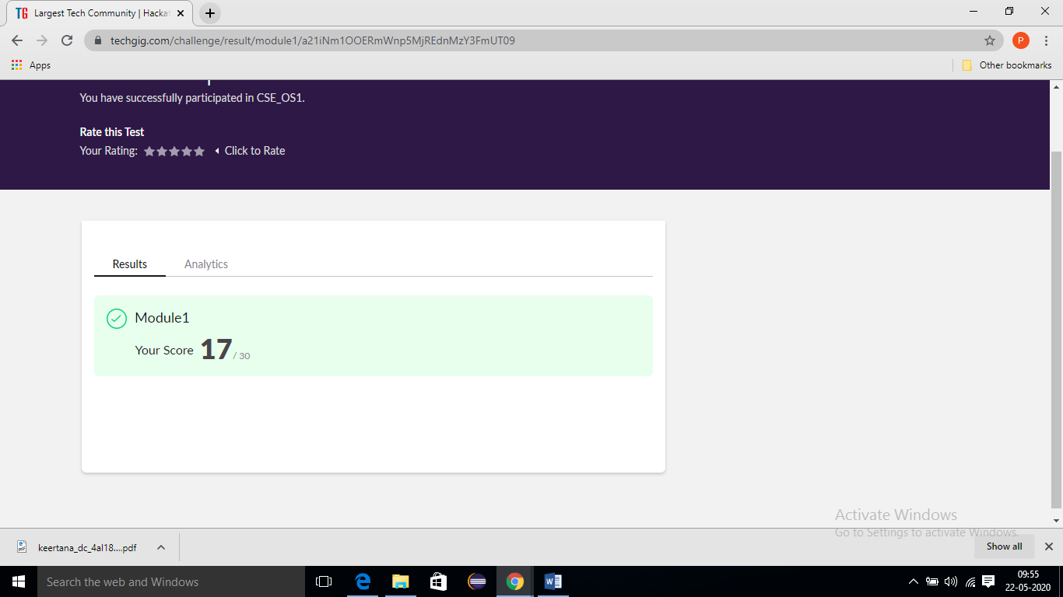

**Online Certification Course Summary:** Today I have learnt about conditional statements and Loops and also execute the some of the basic conditional statements programs and loops.

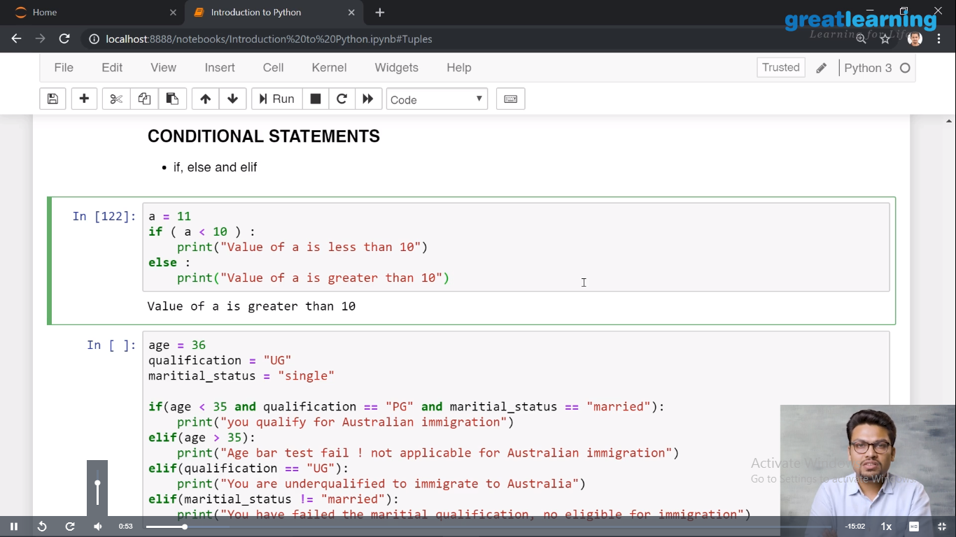

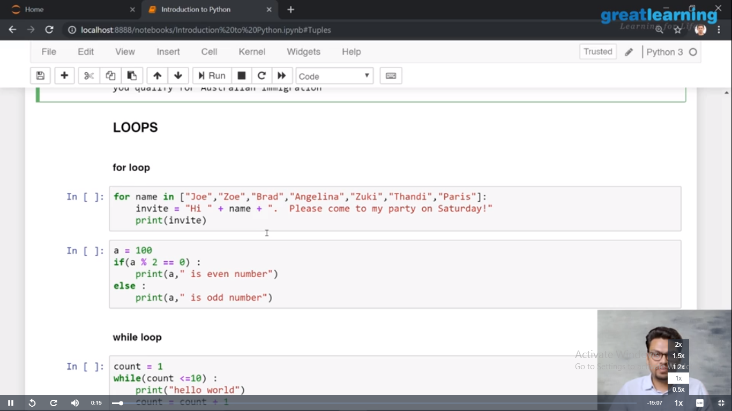

**Online Coding Summary:**Today I received one program from Prof.HARSHITHA CSE Dept. The program is mentioned above. to my GitHub repository and I’ve shared the snapshot below.

